Week7_Ticket Raising App using React Forms (ticketraisingapp)

Objective:
- Create a React App named “ticketraisingapp” which will help to raise a complaint and get it resolved.
- Create a component named “ComplaintRegister” with a form containing a textbox to enter the employee name and a textarea to enter the complaint. Use “handleSubmit” event of the button to submit the complaint and generate a Reference number for further follow ups in the alert box.

Phase 1: Setting Up Your Development Environment
Step 1: Install Node.js and npm
- Explanation: Node.js is a JavaScript runtime that lets you run JavaScript on your computer. npm is the package manager for Node.js, used to install and manage project dependencies like React.
- Action:
- Open a web browser and navigate to the official Node.js download page: https://nodejs.org/en/download/
Step 2: Install Visual Studio Code
- Explanation: Visual Studio Code (VS Code) is a free, powerful code editor that is highly recommended for React development.
- Action:
- Go to the official VS Code website: https://code.visualstudio.com/
- Download and run the installer for your operating system.

Phase 2: Creating and Running the React Application
Step 3: Create the React Application
- In your command prompt or terminal, navigate to the directory where you want to store your project (e.g., your Desktop or a development folder).
- Type the following command and press Enter. This may take a few minutes to complete.
npx create-react-app ticketraisingapp
Step 4: Navigate into Your New Project Folder
- You must be inside the project folder to run commands related to this specific application.
- Once the command from Step 4 is finished, type the following command to move into the newly created directory:
cd ticketraisingapp
Step 5: Open the Project in Visual Studio Code
- This command opens the entire project folder in VS Code, allowing you to easily browse and edit the project files.
- Type the command:
code .
Note: The . tells VS Code to open the current directory.

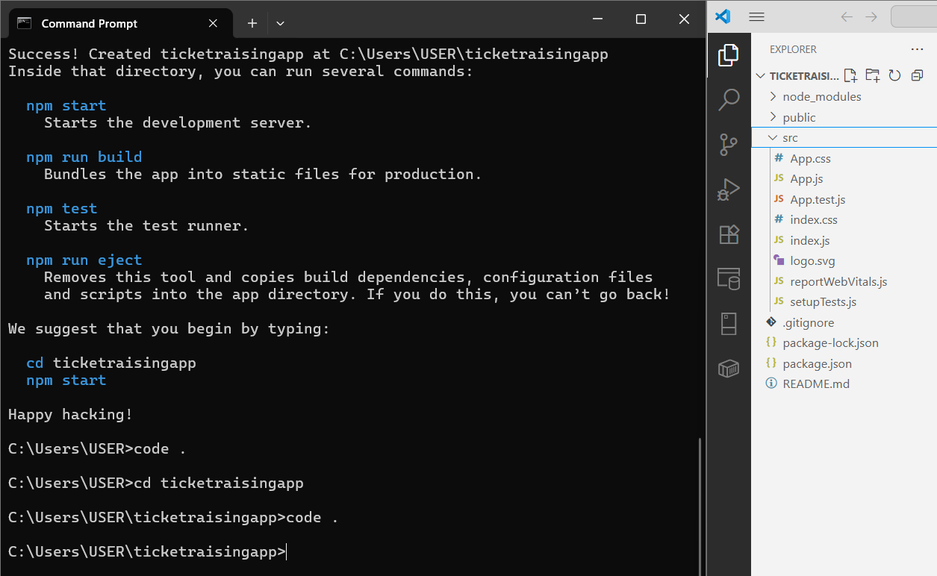
Step 6: Create the ComplaintRegister.js File
- In the VS Code explorer, right-click the src folder.
- Select "New File" and name it ComplaintRegister.js.
import React, { Component } from 'react';
class ComplaintRegister extends Component {
constructor() {
super();
this.state = {
ename: '',
complaint: '',
NumberHolder: Math.floor(Math.random() * 1000) + 1
};
}
handleChange = (event) => {
this.setState({ [event.target.name]: event.target.value });
};
handleSubmit = (event) => {
const msg = `Thanks ${this.state.ename}\nYour Complaint was Submitted.\nTransaction ID: ${this.state.NumberHolder}`;
alert(msg);
event.preventDefault();
};
render() {
return (
<div style={{ textAlign: 'center', marginTop: '50px' }}>
<h2 style={{ color: 'red' }}>Register your complaints here!!!</h2>
<form onSubmit={this.handleSubmit}>
<label>
Name:
<input
type="text"
name="ename"
value={this.state.ename}
onChange={this.handleChange}
required
style={{ marginLeft: '10px' }}
/>
</label>
<br /><br />
<label>
Complaint:
<textarea
name="complaint"
value={this.state.complaint}
onChange={this.handleChange}
required
style={{ marginLeft: '10px' }}
/>
</label>
<br /><br />
<button type="submit">Submit</button>
</form>
</div>
);
}
}
export default ComplaintRegister;
Step 7: Edit the Main App.js File
- Open the App.js file from the src folder.
- Replace all of its content with this code:
import React from 'react';
import ComplaintRegister from './ComplaintRegister';
function App() {
return (
<div className="App">
<ComplaintRegister />
</div>
);
}
export default App;
Step 8: Run the Application
- Go back to your terminal (it should still be in the ticketraisingapp folder).
- Run the start command:
npm start

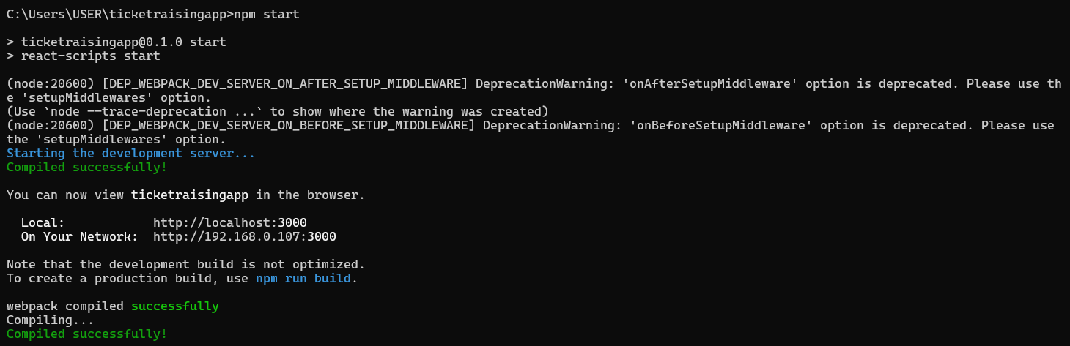

Step 9: View Your Application
- The development server hosts your application on a local port, typically 3000.
Local: http://localhost:3000
On Your Network: http://192.168.0.107:3000

Output:

